Krugman Module 19 – AD/AS Equilibrium
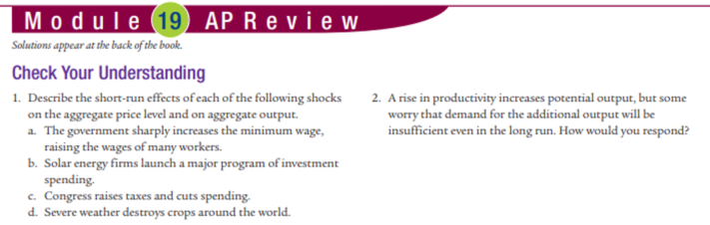
MC 1.c 2.a 3.d 4.b 5.b
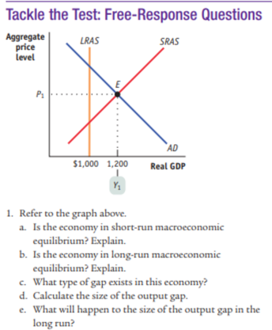
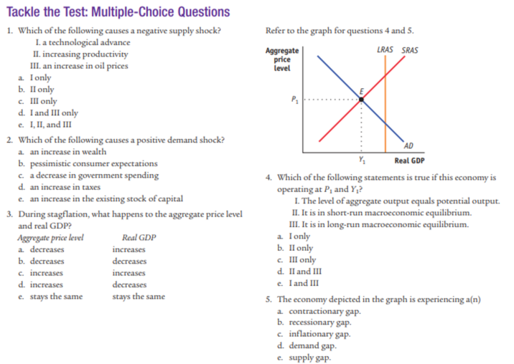
Free Response: a. yes b. all curves don’t intersect. C. positive d. 200 e. go to zero
Check your understanding: 1. a. SRAS shift left, PL increase, Output decrease b. shift AD to right. PL increase, output increase. C. increase taxes decrease AD, decrease PL and output d. negative supply shock (SRAS shift left)
2. LRAS shifts to right. We move along AD because the price level is lower so people will buy more. There will be a new equilibrium and no lack of demand.
